**Front End:**

from django.contrib.auth.backends import ModelBackend

from django.contrib.auth import get_user_model

class EmailBackend(ModelBackend):

def authenticate(self, username=None, password=None, **kwargs):

UserModel = get_user_model()

try:

user = UserModel.objects.get(email=username)

except UserModel.DoesNotExist:

return None

else:

if user.check_password(password):

return user

return None

**Create a model for the poll:**

from django.db import models

class Poll(models.Model):

question = models.TextField()

option_one = models.CharField(max_length=30)

option_two = models.CharField(max_length=30)

option_three = models.CharField(max_length=30)

option_one_count = models.IntegerField(default=0)

option_two_count = models.IntegerField(default=0)

option_three_count = models.IntegerField(default=0)

def total(self):

return self.option_one_count + self.option_two_count + self.option_three_count

**Create a Form for the Poll:**

from django import forms

from .models import Poll

class PollForm(forms.ModelForm):

class Meta:

model = Poll

fields = ['question', 'option_one', 'option_two', 'option_three']

**Create a View for the Poll:**

**from django.shortcuts import render, redirect**

**from .models import Poll**

**from .forms import PollForm**

**def home(request):**

**if request.method == 'POST':**

**form = PollForm(request.POST)**

**if form.is_valid():**

**form.save()**

**return redirect('home')**

**else:**

**polls = Poll.objects.all()**

**form = PollForm()**

**context =**

**{**

**'polls': polls,**

**'form': form**

**}**

**return render(request, 'poll/home.html', context)**

**Create a Template for the Poll:**

**{% extends "poll/base.html" %}**

**{% block title %}Home{% endblock %}**

**{% block content %}**

**<h1>Polls</h1>**

**<form method="POST">**

**{% csrf_token %}**

**{{ form.as_p }}**

**<button type="submit" class="btn btn-primary">Submit</button>**

**</form>**

**<ul>**

**{% for poll in polls %}**

**<li>{{ poll.question }}**

**<ul>**

**<li>{{ poll.option_one }} ({{ poll.option_one_count }})</li>**

**<li>{{ poll.option_two }} ({{ poll.option_two_count }})</li>**

**<li>{{ poll.option_three }} ({{ poll.option_three_count }})</li>**

**</ul>**

**</li>**

**form method="post">**

**{% csrf_token %}**

**{{ form.as_p }}**

**<button type="submit">Create Poll</button>**

**</form>**

**{% endfor %}**

**</ul>**

**{% endblo**ck%}

{% block content %}

<h1>Polls</h1>

<ul>

{% for poll in polls %}

<li>

<a href="{% url 'polls:vote' poll.id %}">{{ poll.question }}</a>

</li>

{% empty %}

<li>No polls yet.</li>

{% endfor %}

</ul>

{% endblock %}

{% extends 'base.html' %}

{% block content %}

<h1>{{ poll.question }}</h1>

<form method="post">

{% csrf_token %}

<input type="radio" name="selected_option" value="option_one" id="option_one">

<label for="option_one">{{ poll.option_one }}</label><br>

<input type="radio" name="selected_option" value="option_two" id="option_two” id=”option_two”>

<label for=”option_two”>{{poll.option_two}}</label>

**Requirements:**

Django==3.1.1

mysql-connector==2.2.9

virtualenv==20.0.31

django-renderpdf==3.0.1

requests==2.24.0

**To run the application, follow these steps:**

1.Activate the virtual environment

2.Clone the project from the repository

3.Install the requirements

4.Run migrations

5.Run the server.

**Code To Run:**

$ source venv/scripts/activate

$ git clone https://github.com/jobic10/e-voting-with-django.git

$ cd e-voting-with-django

$ pip3 install -r requirements.txt

$ python manage.py makemigrations

$ python manage.py migrate

$ python manage.py runserver.

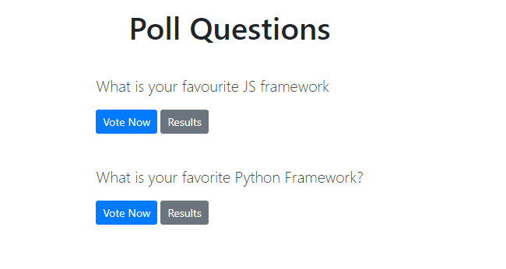**OUTPUT:**

